**2016011974 刘喆**

**操作系统第二次课后练习**

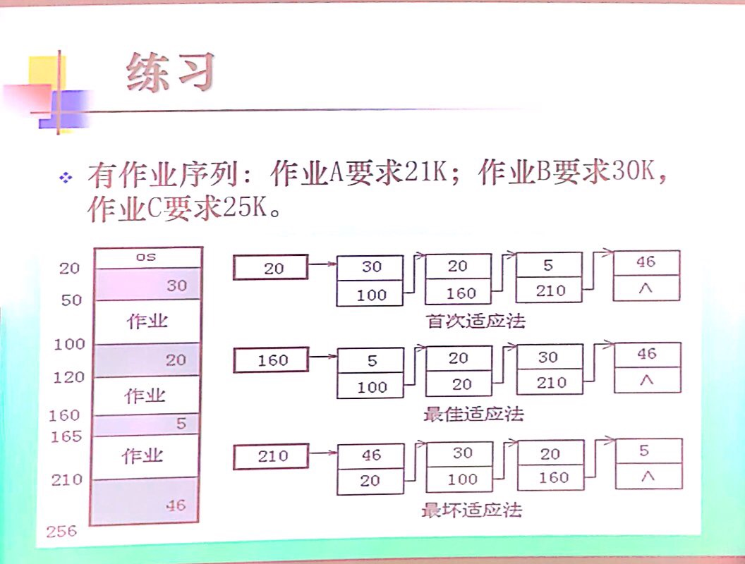

**一、首次适应算法：**

从链首开始循环查找，直到找到一个大小满足要求的空闲分区为止。

空闲分区按照30,20,5,46的顺序分配给作业。

|  |  |  |  |  |  |  |  |  |
| --- | --- | --- | --- | --- | --- | --- | --- | --- |
| 20 |  | 30 |  | 20 |  | 5 |  | 46 |
| 100 | 160 | 210 | ^ |

分配作业A

|  |  |  |  |  |  |  |  |  |
| --- | --- | --- | --- | --- | --- | --- | --- | --- |
| 41 |  | 9 |  | 20 |  | 5 |  | 46 |
| 100 | 160 | 210 | ^ |

分配作业B

|  |  |  |  |  |  |  |  |  |
| --- | --- | --- | --- | --- | --- | --- | --- | --- |
| 41 |  | 9 |  | 20 |  | 5 |  | 16 |
| 100 | 160 | 240 | ^ |

不能分配作业C：从链首至链尾找不到适合C的空间，分配失败。

**二、最佳适应算法：**

将所有空闲区按其容量从小到大的顺序形成空闲分区链查找。

空闲分区按照5,20,30,46的顺序分配给作业。

|  |  |  |  |  |  |  |  |  |
| --- | --- | --- | --- | --- | --- | --- | --- | --- |
| 160 |  | 5 |  | 20 |  | 30 |  | 46 |
| 100 | 20 | 210 | ^ |

分配作业A

|  |  |  |  |  |  |  |  |  |
| --- | --- | --- | --- | --- | --- | --- | --- | --- |
| 160 |  | 5 |  | 9 |  | 20 |  | 46 |
| 41 | 100 | 210 | ^ |

分配作业B

|  |  |  |  |  |  |  |  |  |
| --- | --- | --- | --- | --- | --- | --- | --- | --- |
| 160 |  | 5 |  | 9 |  | 16 |  | 20 |
| 41 | 240 | 100 | ^ |

不能分配作业C：找不到适合作业C的空间，分配失败。

**三、最坏适应算法：**

将所有空闲区按其容量从大到小的顺序形成空闲分区链查找。

空闲分区按照46,30,20,5的顺序分配给作业。

|  |  |  |  |  |  |  |  |  |
| --- | --- | --- | --- | --- | --- | --- | --- | --- |
| 210 |  | 46 |  | 30 |  | 20 |  | 5 |
| 20 | 100 | 160 | ^ |

分配作业A

|  |  |  |  |  |  |  |  |  |
| --- | --- | --- | --- | --- | --- | --- | --- | --- |
| 20 |  | 30 |  | 25 |  | 20 |  | 5 |
| 231 | 100 | 160 | ^ |

分配作业B

|  |  |  |  |  |  |  |
| --- | --- | --- | --- | --- | --- | --- |
| 231 |  | 25 |  | 20 |  | 5 |
| 100 | 160 | ^ |

分配作业C

|  |  |  |  |  |
| --- | --- | --- | --- | --- |
| 100 |  | 20 |  | 5 |
| 160 | ^ |

综上所述：只有最坏适应算法能够完成分配，首次适应算法和最佳适应算法皆无法完成分配。